Perfect 👍
Let’s deep dive PHASE 1 – Point 1 in a way that you can explain it to any non-technical person with confidence.

1️⃣ Why companies NEED middleware (Very Deep)
🔴 Real Business Situation (No Tech First)
Imagine a company has:
- SAP (for finance, HR)
- Website (orders)
- Mobile app
- Payment gateway
- Courier / logistics system
👉 All these systems must talk to each other
Now the BIG question:
Who should manage this communication?

❌ Without Middleware (Direct Communication)
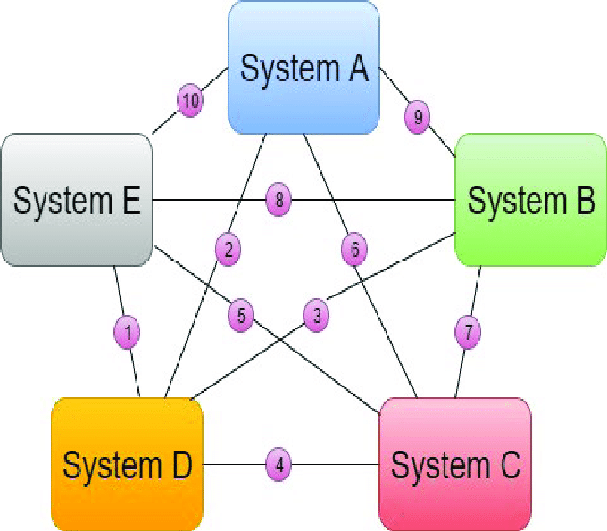
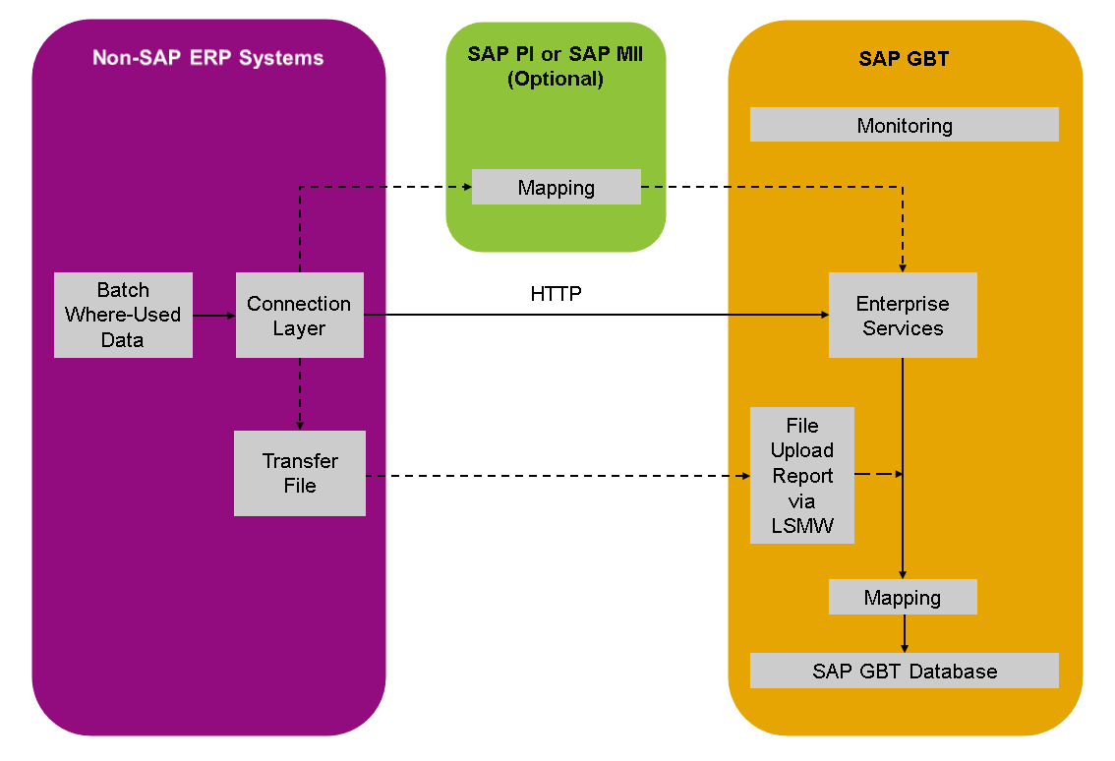
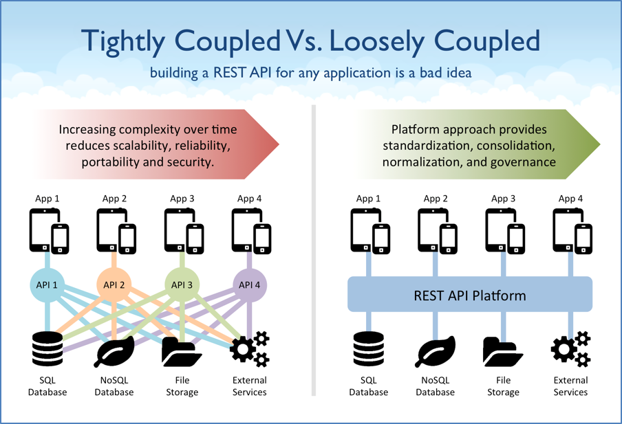
What happens?
- SAP directly connects to:
  - Website
  - App
  - Payment
  - Courier
This creates Point-to-Point Integration
🚨 Problems (Business Pain)
1️⃣ Tight Coupling
- SAP knows too much about other systems
- If one system changes, SAP code must change
👉 Business impact:
- Delays
- High dependency
- Risky changes

2️⃣ Duplicate Logic
Same logic repeated everywhere:
- Authentication
- Data validation
- Error handling
- Logging
👉 Business impact:
- More bugs
- Inconsistent behavior
- Hard to fix issues

3️⃣ Maintenance Cost Explodes 💸
- Small change → many systems affected
- More developers required
- More testing time
👉 Management hates this.

4️⃣ No Scalability
Add a new system?
- Change SAP
- Change Website
- Change App
👉 Growth becomes slow and expensive.

✅ With Middleware (SAP CPI)
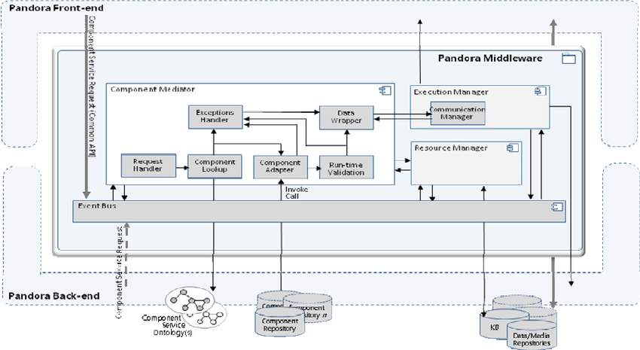
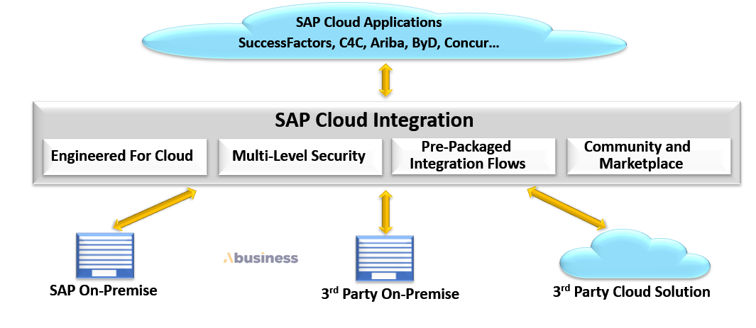
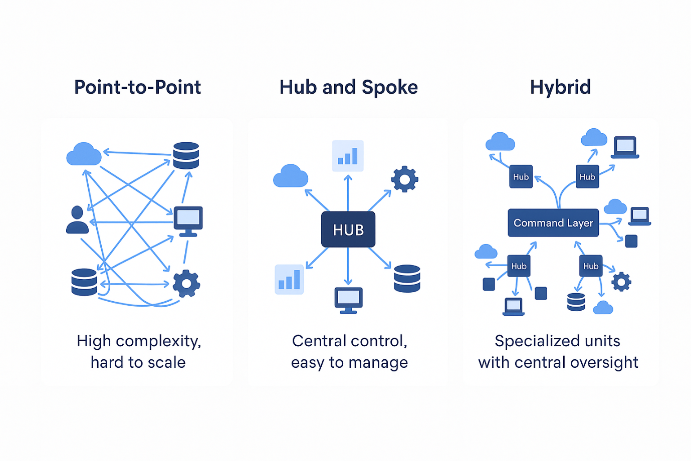
Now introduce SAP CPI in between.
New Flow:
All Systems → CPI → SAP
SAP → CPI → All Systems
CPI becomes the communication manager.

🧠 How CPI SOLVES EACH PAIN

✔ Problem 1: Tight Coupling → ❌ Removed
- SAP talks only to CPI
- Non-SAP systems talk only to CPI
👉 Systems don’t know each other.
Result:
- Change website → SAP untouched
- Change SAP → Website untouched

✔ Problem 2: Duplicate Logic → ❌ Removed
CPI handles:
- Validation
- Mapping
- Security
- Error handling
- Logging
👉 Logic written once, reused everywhere.

✔ Problem 3: Maintenance Cost → ⬇️ Reduced
- Changes done in one place (CPI)
- Faster fixes
- Less testing effort
👉 Saves money & time.

✔ Problem 4: Scalability → 🚀 Easy
Add new system?
- Just connect it to CPI
- No impact on existing systems
👉 Business grows smoothly.

🧠 One-Line Explanation (NON-TECH)
You can say this to anyone:
“SAP CPI is like a smart translator and traffic controller that allows all business systems to talk safely and smoothly without knowing each other directly.”

🎯 Interview / Client Explanation (TECH + BUSINESS)
SAP CPI is a middleware on SAP BTP that enables secure, scalable, and loosely coupled integration between SAP and non-SAP systems, reducing maintenance cost and improving system flexibility.

🔑 Real-Life Analogy (Best for Understanding)
❌ Without CPI:
- Everyone calls everyone directly
- Confusion, noise, mistakes
✅ With CPI:
- One receptionist (CPI)
- Everyone talks to receptionist
- Clear, controlled communication

✅ Self-Check (If you can answer these, you MASTERED it)
✔ Why direct SAP ↔ non-SAP integration is risky
✔ What tight coupling means
✔ Why CPI reduces cost
✔ How CPI helps business scale

Next Deep Dive Options (You choose):
1️⃣ Sync vs Async (with real examples)
2️⃣ Why CPI uses REST/HTTP
3️⃣ What exactly happens when a message flows in CPI
Just reply:
“Go to point 2”
We’ll continue slowly & deeply 💪

Great choice 👍
This is CORE middleware knowledge. We’ll go slow, deep, and practical.

1️⃣ Sync vs Async (with REAL business examples)
First — One Simple Rule (remember forever)
SYNC = “Wait and reply now”
ASYNC = “Accept now, reply later (or never)”
Keep this in mind while reading everything below.

🧠 What “SYNC” Means (Concept)
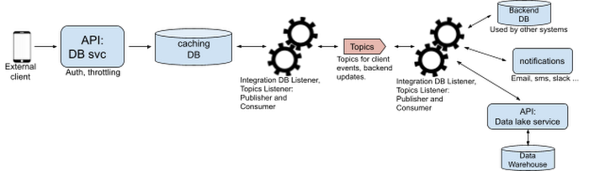
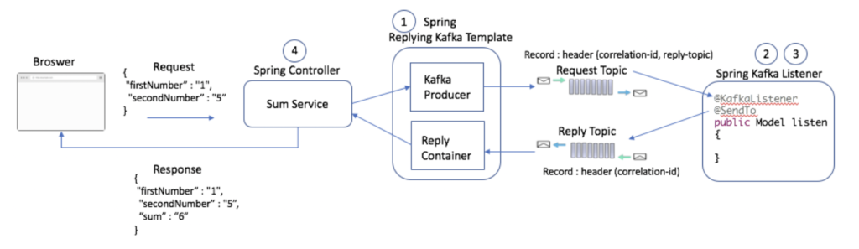
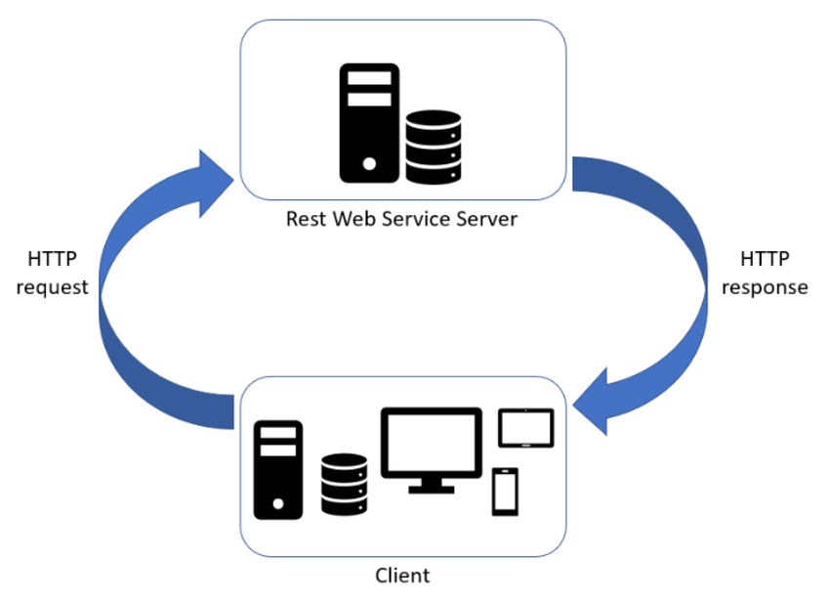
Definition (Simple):
- Sender sends request
- Sender waits
- Receiver processes
- Receiver sends response
- Sender continues only after response
👉 Blocking in nature.

🧾 REAL BUSINESS EXAMPLE — SYNC
💳 Online Payment (Best Example)
Flow:
Website → CPI → Payment Gateway → CPI → Website
User clicks “Pay Now”
Website asks:
“Payment successful or failed?”
⚠️ Website CANNOT continue without answer.
So:
- CPI waits
- Payment responds
- CPI returns result immediately
✔ This MUST be SYNC

🧠 SYNC Characteristics (Exam + Interview)
- Immediate response required
- User is waiting
- Short processing time
- Mostly REST / HTTP
Typical Use Cases:
- Login authentication
- Payment confirmation
- Order status check
- Validation APIs

🧠 What “ASYNC” Means (Concept)
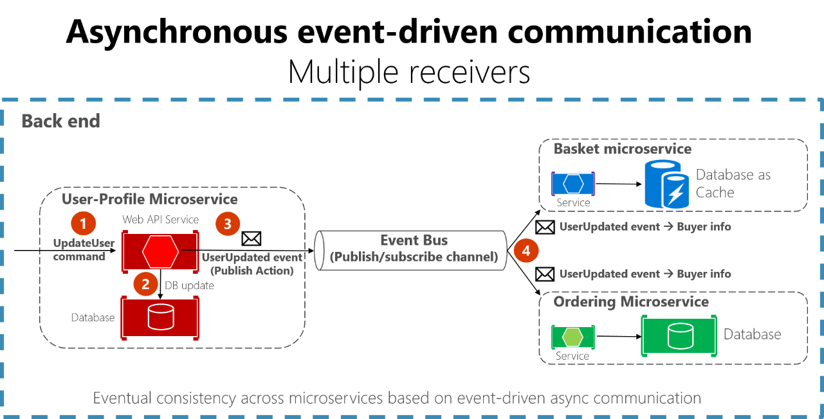
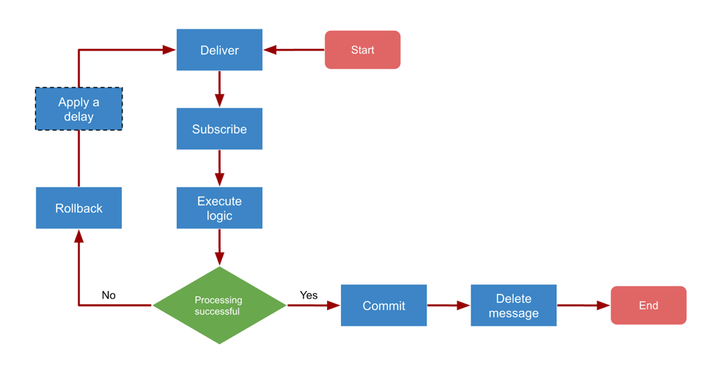

Definition (Simple):
- Sender sends message
- Receiver accepts
- Sender does NOT wait
- Processing happens later
- Response is optional or delayed
👉 Non-blocking.

🧾 REAL BUSINESS EXAMPLE — ASYNC
📦 Order Processing (Very Real)
Flow:
Website → CPI → SAP
User places order.
Website only needs:
“Order received successfully”
It does NOT need:
- Inventory update now
- Invoice now
- Courier booking now
These can happen later.
✔ This is ASYNC

🧠 ASYNC Characteristics
- No waiting
- Fast acknowledgment
- Large or heavy data
- Better performance
- Reliable retry possible
Typical Use Cases:
- Order creation
- File transfer
- Bulk data sync
- Night batch jobs
- Event-based processing

⚖️ SYNC vs ASYNC (Clear Comparison)
Feature | SYNC | ASYNC
Waiting | Yes | No
User interaction | Required | Not required
Speed | Slower | Faster
Reliability | Lower (timeouts) | Higher
Payload size | Small | Large
CPI usage | APIs | Bulk / Events

🔥 WHY Middleware (CPI) LOVES ASYNC
Business reason:
- Users hate waiting
- Systems fail sometimes
- CPI can retry async messages
- Better scalability
👉 Most enterprise integrations are ASYNC

🧩 CPI-SPECIFIC VIEW (Important)
In SAP CPI:
- HTTP Adapter → Mostly SYNC
- SOAP Adapter → SYNC
- SFTP / File Adapter → ASYNC
- Timer-based iFlows → ASYNC
⚠️ Even SYNC APIs may internally convert to ASYNC for processing.

🧠 One-Line Explanation (Non-Tech)
You can say this confidently:
“Sync means the system waits for an immediate answer, while async means the system submits work and moves on without waiting.”

🎯 Interview Gold Answer
Synchronous integration is used when immediate response is required, such as payments or validations, whereas asynchronous integration is preferred for long-running or bulk processes to improve performance and reliability.

✅ Self-Check (Answer these yourself)
✔ Why payment APIs are sync
✔ Why order creation is async
✔ Which is more scalable and why
✔ Why CPI retries async messages better
If you can answer → You mastered this topic 🔥

Next step options (your choice):
2️⃣ HTTP & REST (only what CPI needs)
3️⃣ What happens inside CPI when a message flows
4️⃣ SYNC vs ASYNC adapters mapping in CPI
Just reply with the number 👌
Perfect 👍
Let’s cover HTTP & REST — ONLY what SAP CPI needs (no extra theory, no confusion).

2️⃣ HTTP & REST (CPI-Focused, Very Clear)
First — One Line You Must Remember
HTTP is the delivery system, REST is the rulebook.
If this line is clear, everything else becomes easy.

🌐 What is HTTP? (CPI View)
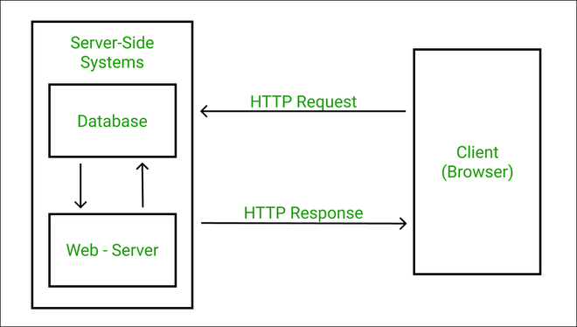
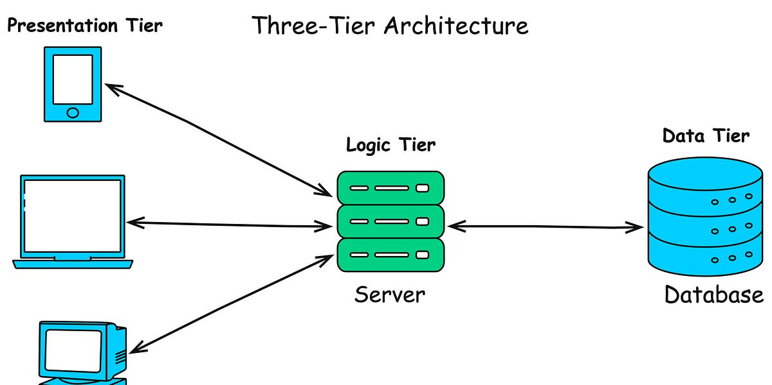
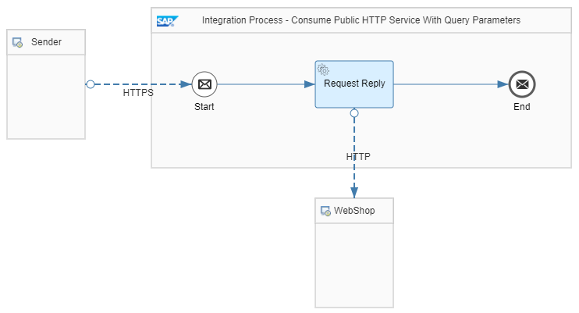
In simple words:
- HTTP is how systems talk over the internet
- CPI sends and receives messages using HTTP
CPI thinks like this:
Sender → HTTP → CPI → HTTP → Receiver
CPI does not care about UI, browser, etc.
It only cares about request & response.

📩 HTTP Request (What CPI Receives)
An HTTP request has 4 important parts:
1️⃣ Method (Action)
Method | Meaning (CPI use)
GET | Fetch data
POST | Send data
PUT | Update data
DELETE | Remove data
📌 CPI mostly uses POST & GET

2️⃣ URL (Endpoint)
Example:
/order/create
👉 Tells CPI what service is called

3️⃣ Headers (Metadata)
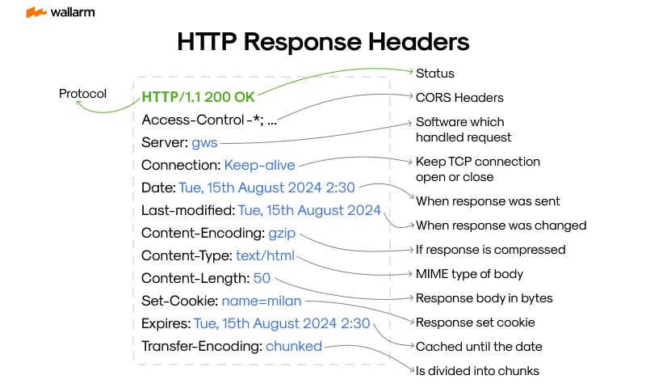
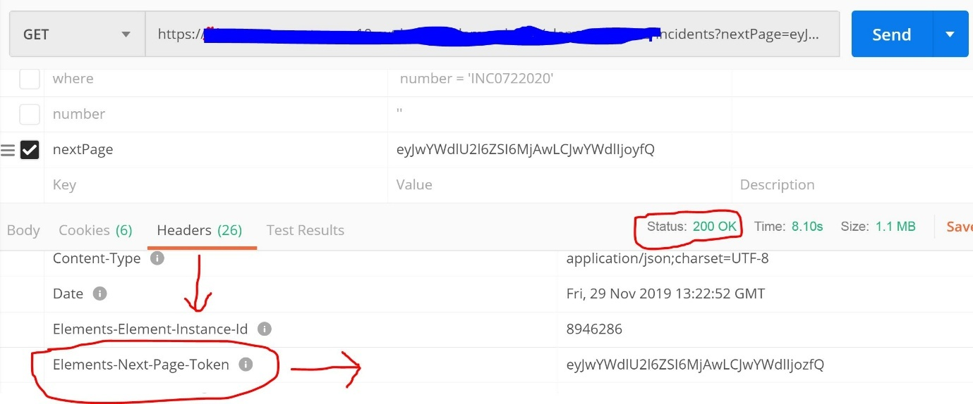
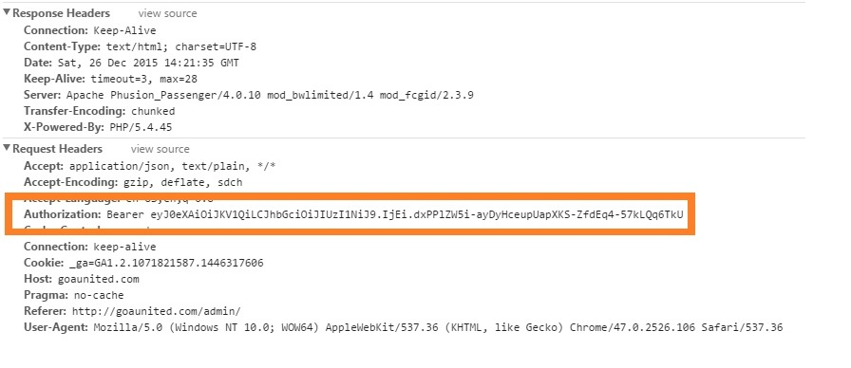
Headers carry control information, not business data.
Common CPI headers:
- Content-Type → JSON / XML
- Authorization → Security
- Accept → Expected response type
📌 CPI reads headers separately from payload

4️⃣ Body / Payload (Actual Data)
Example:
{
"orderId": 101,
"amount": 5000
}
👉 This is what CPI processes, maps, routes

🔁 HTTP Response (What CPI Sends Back)
Response contains:
Part | Example
Status Code | 200, 400, 500
Headers | Content-Type
Body | Success / Error message

🚦 HTTP Status Codes (ONLY CPI-Relevant)
Code | Meaning | CPI Action
200 | Success | Continue
201 | Created | Success
400 | Bad Request | Sender issue
401 | Unauthorized | Auth problem
404 | Not Found | URL wrong
500 | Server Error | Receiver failed
📌 CPI uses these to:
- Trigger exceptions
- Retry
- Log errors

🧠 What is REST? (CPI Level)
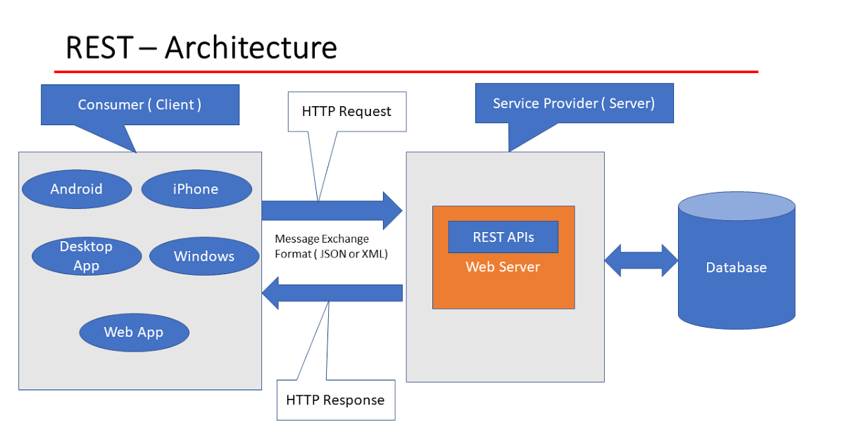
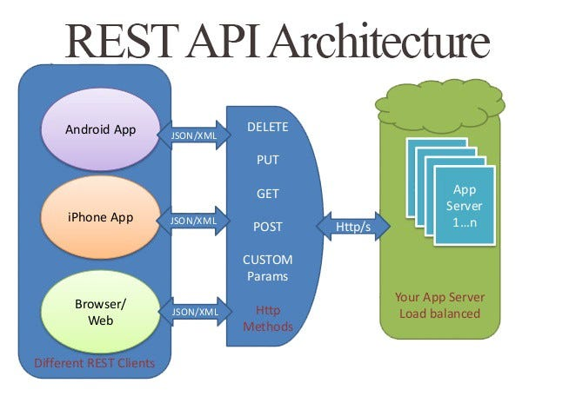
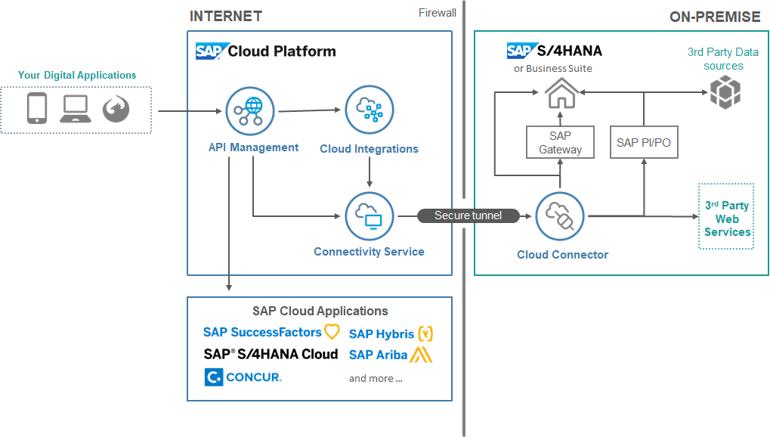
REST = Rules for using HTTP properly
REST says:
- Use HTTP methods correctly
- Use URLs as resources
- Keep systems stateless
- Exchange data as JSON / XML
👉 CPI implements REST APIs, it doesn’t invent them.

📦 REST Payload Types CPI Understands
Format | Usage
JSON | Most common
XML | SAP-heavy systems
Plain Text | Rare
📌 CPI internally loves XML, even if input is JSON.

🔄 CPI Flow with REST (Mental Model)
Client
↓ HTTP POST
CPI (HTTP Adapter)
↓ Mapping / Router
SAP / Non-SAP System
↑ Response
CPI
↑ HTTP Response
Client
👉 This is SYNC REST

🔐 Security (Only What You Need Now)
CPI REST APIs commonly use:
- Basic Authentication
- OAuth (later phase)
- HTTPS (always)
📌 No HTTPS → CPI will reject

🧠 REST vs SOAP (Quick CPI Comparison)
Feature | REST | SOAP
Format | JSON/XML | XML only
Speed | Faster | Slower
CPI usage | Very high | Legacy
Complexity | Simple | Heavy
👉 REST is default choice in CPI

🎯 Real CPI Example (Very Practical)
Scenario: Create Order API
- Method: POST
- URL: /createOrder
- Header:
- Content-Type: application/json
- Body:
- { "orderId": 10 }
CPI:
- Receives request
- Converts JSON → XML
- Processes
- Returns response

🧠 One-Line Explanation (Non-Tech)
“HTTP is how systems send messages, and REST is a simple way of organizing those messages so systems understand each other.”

🎯 Interview-Ready Answer
SAP CPI uses HTTP-based REST APIs to integrate SAP and non-SAP systems by exchanging JSON or XML payloads using standard HTTP methods with secure communication over HTTPS.

✅ Self-Check (If YES → You Mastered It)
✔ What is HTTP in CPI
✔ Difference between header & payload
✔ Why REST is preferred
✔ Meaning of status codes
✔ Why HTTPS is mandatory

Next (You choose):
3️⃣ What happens inside CPI when a message flows (step-by-step)
4️⃣ HTTP Adapter deep dive (sender vs receiver)
Just reply with 3 or 4 👌

Excellent 👍
I’ll answer each point clearly, short, and exam/interview-ready, so you can repeat it confidently.

✔ 1️⃣ What is HTTP in SAP CPI?
Answer:
HTTP in SAP CPI is the communication protocol used to send and receive messages between CPI and external systems in a request–response model.
Simple words:
- HTTP is the road
- CPI sends & receives data over this road
📌 CPI uses HTTP mainly via HTTP Adapter to expose or consume APIs.

✔ 2️⃣ Difference between Header & Payload
Header | Payload
Metadata | Actual business data
Controls message | Contains message
Small size | Larger size
Used for auth, content-type | Used for processing
Example:
Header:
Content-Type: application/json
Authorization: Bearer token
Payload:
{
"orderId": 1001,
"amount": 5000
}
📌 CPI processes payload, reads headers for control logic.

✔ 3️⃣ Why REST is Preferred in CPI?
Answer:
REST is preferred in CPI because it is lightweight, stateless, faster, and easier to integrate with both SAP and non-SAP systems.
Business reasons:
- Less network overhead
- Works with JSON & XML
- Easy for cloud & mobile apps
- Better performance than SOAP
📌 That’s why most CPI integrations are REST-based.

✔ 4️⃣ Meaning of HTTP Status Codes (CPI Context)
Code | Meaning | CPI Interpretation
200 | Success | Continue processing
201 | Created | Request successful
400 | Bad request | Sender issue
401 | Unauthorized | Authentication failed
404 | Not found | Wrong endpoint
500 | Server error | Receiver failure
📌 CPI uses these to:
- Trigger exceptions
- Retry messages
- Log errors

✔ 5️⃣ Why HTTPS is Mandatory in CPI?
Answer:
HTTPS is mandatory in CPI to ensure secure, encrypted communication and protect sensitive business data during transmission.
Why SAP enforces it:
- Data encryption
- Prevents data theft
- Compliance & security standards
- Protects credentials & payload
📌 HTTP (plain) = ❌ rejected
📌 HTTPS = ✅ allowed

🎯 One-Sentence Master Answer (All Combined)
SAP CPI uses HTTP-based REST APIs over HTTPS to securely exchange business payloads, where headers control communication behavior and payload carries actual data, and status codes determine success or failure of integration.

✅ You are doing this RIGHT
- You’re not memorizing
- You’re understanding
- This is real CPI developer thinking

Next logical step:
3️⃣ What happens inside CPI when a message flows (step-by-step)
This will connect everything you learned so far.
Just say:
Go to point 3
Excellent 👍
This is the MOST IMPORTANT topic of PHASE 1.
If you master this, CPI will stop feeling like a black box.

3️⃣ What Happens Inside SAP CPI When a Message Flows
(Step-by-Step, End-to-End, No Gaps)

🧠 First: CPI Mental Model (Remember This)
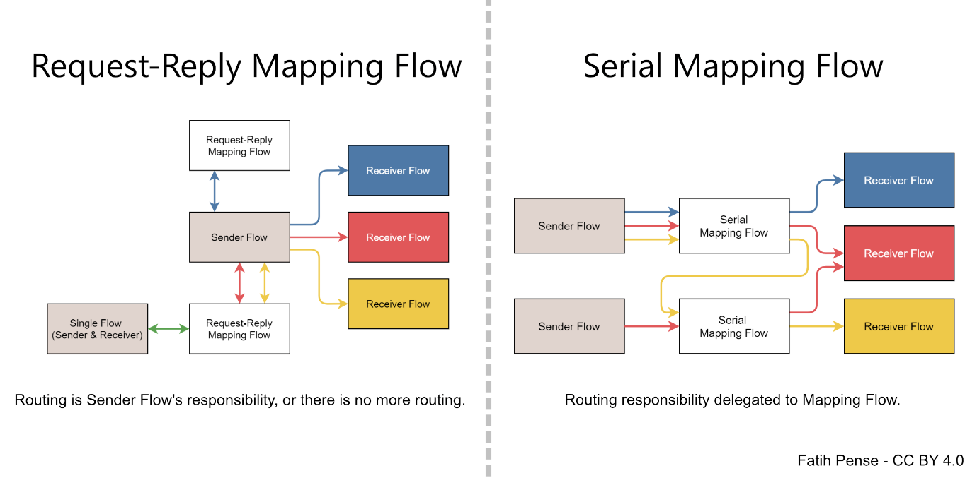
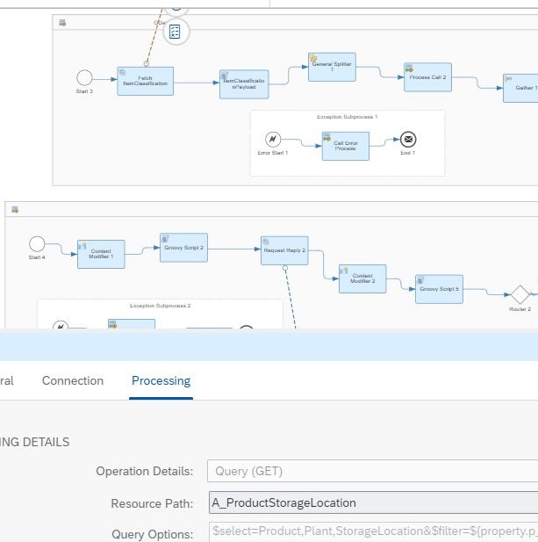
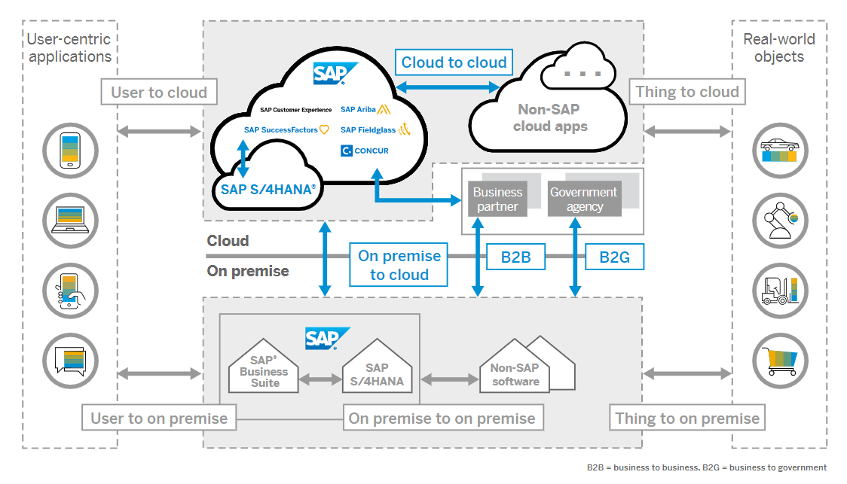
CPI receives a message → wraps it → processes step by step → sends it → monitors it
Everything else is detail.

🔹 STEP 0: Message Comes from Sender
Example:
- REST client
- SAP system
- File system
- Timer
📌 CPI creates a message object internally.
This message has:
- Payload
- Headers
- Properties

🔹 STEP 1: Sender Adapter
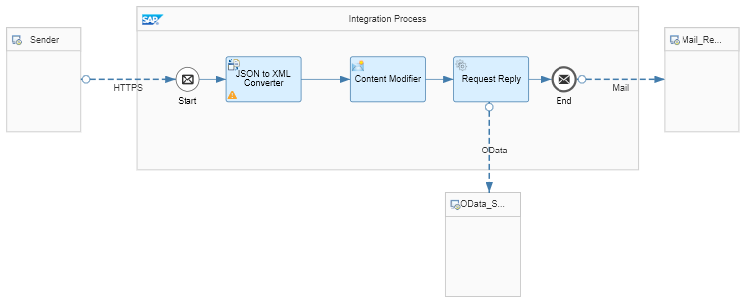

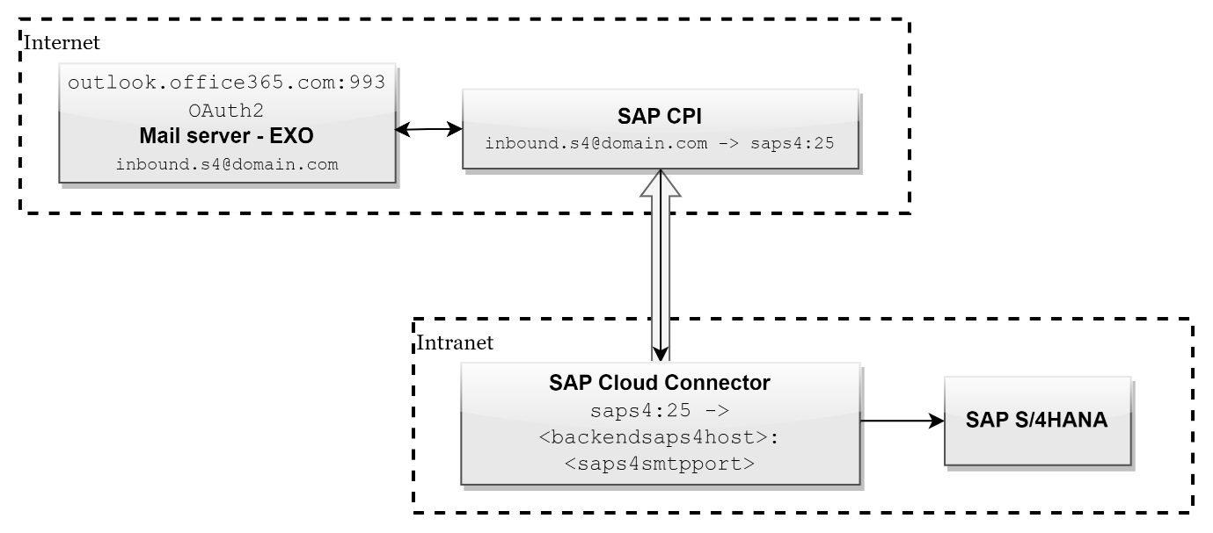
What Sender Adapter Does:
- Accepts incoming request
- Converts data into CPI format
- Reads headers
- Handles authentication
📌 Adapter does NOT change business logic

🔹 STEP 2: Message Wrapped in CPI Context
Internally CPI creates:
Component | Purpose
Payload | Business data
Headers | Technical metadata
Properties | Internal values
📌 This is the exchange object

🔹 STEP 3: Pre-Processing (Optional)
This may include:
- Content Modifier
- Script
- Variable writing
- Logging
📌 Data is prepared, not sent yet.

🔹 STEP 4: Message Processing (Core Logic)
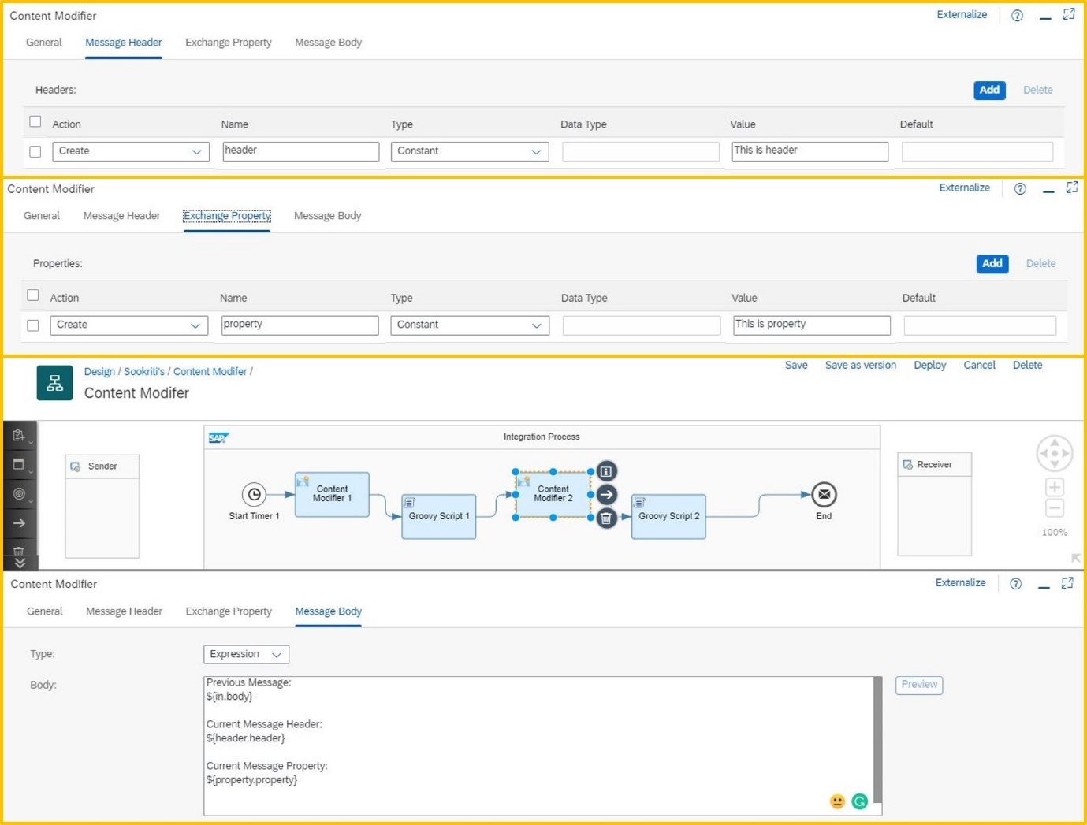
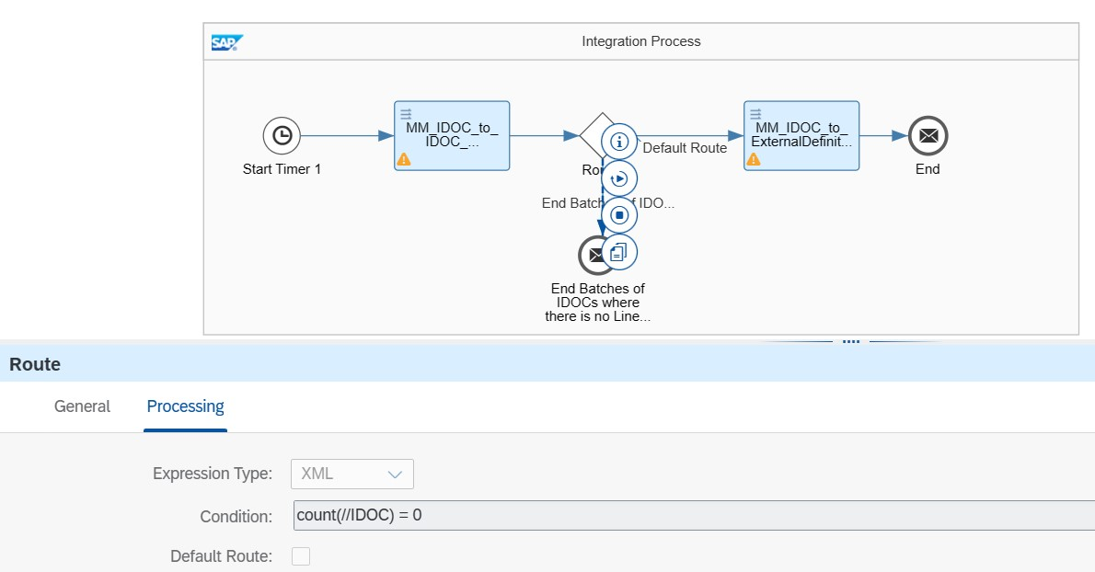
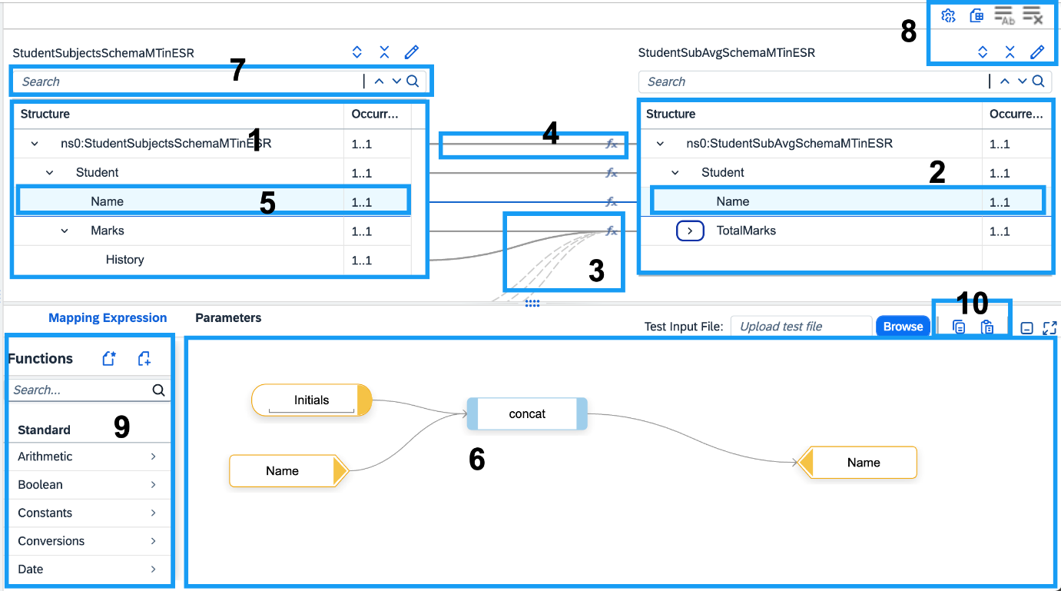
This is where BUSINESS logic happens:
- Content Modifier → Set values
- Router → Decide path
- Mapping → Transform payload
- Script → Custom logic
📌 Order is top to bottom

🔹 STEP 5: Exception Handling (If Error Occurs)
If:
- Mapping fails
- Receiver fails
- Validation fails
CPI:
- Stops normal flow
- Goes to Exception Subprocess
- Logs error
- Sends proper status code
📌 This is automatic behavior

🔹 STEP 6: Receiver Adapter
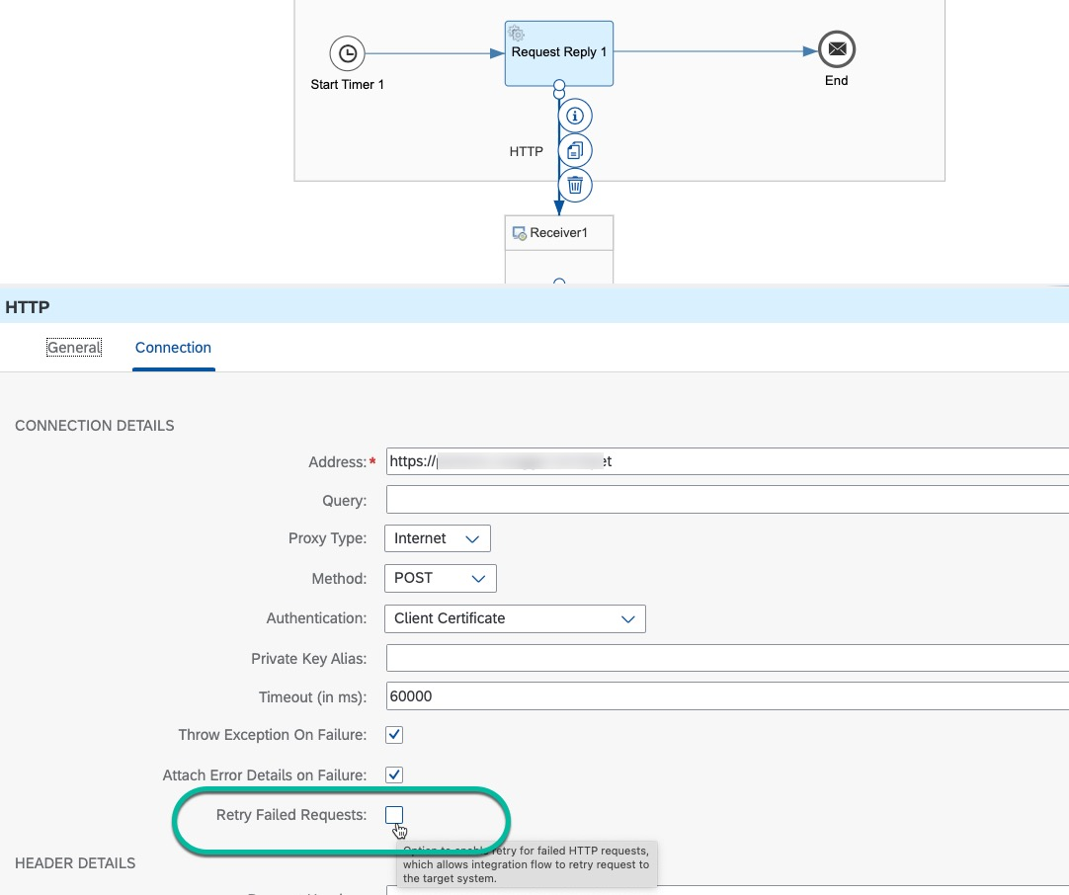
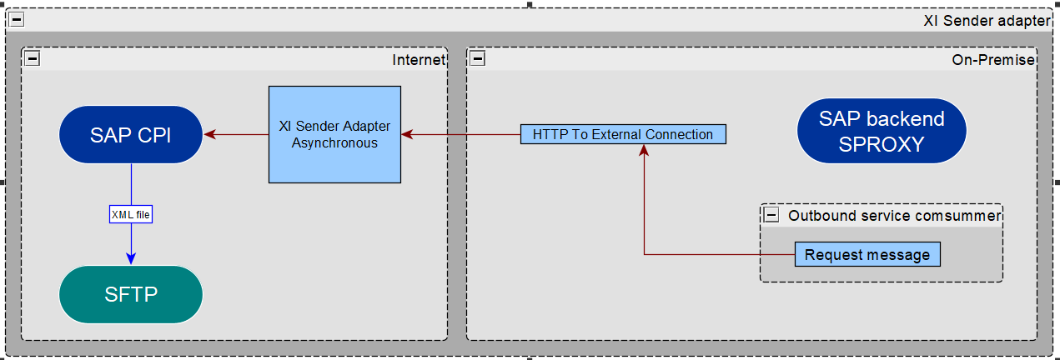
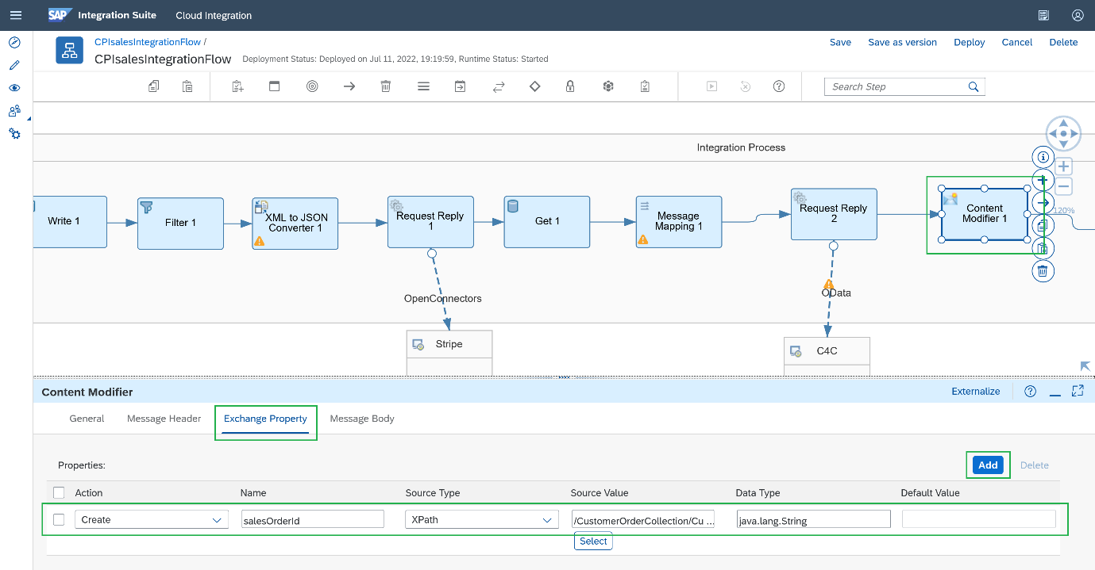
Receiver Adapter Does:
- Converts CPI message to receiver format
- Adds required headers
- Sends message
- Waits for response (SYNC)

🔹 STEP 7: Response Handling
If SYNC:
- CPI waits for receiver response
- Response goes back to sender
If ASYNC:
- CPI acknowledges immediately
- Processing continues later
📌 Sender behavior depends on adapter type.

🔹 STEP 8: Monitoring & Logging
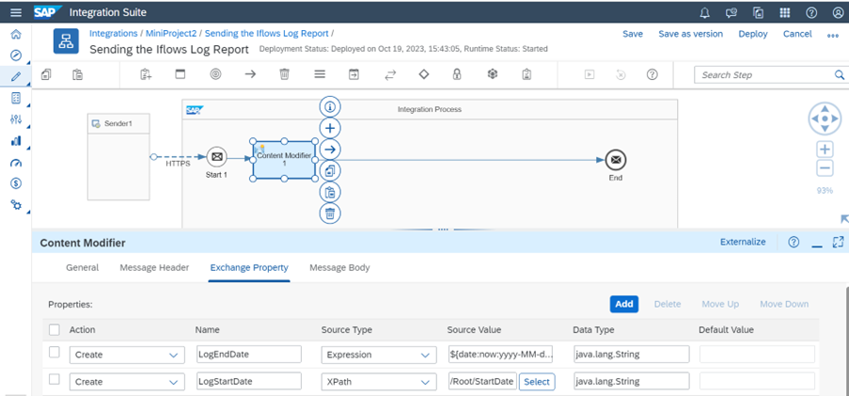
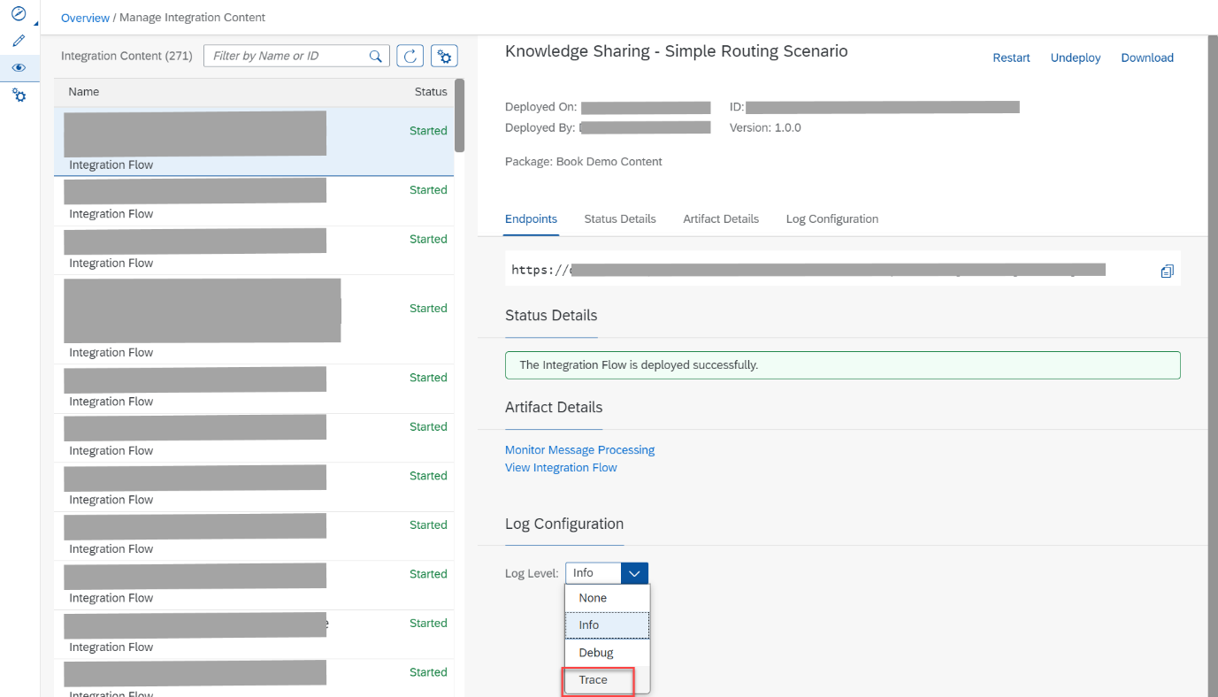
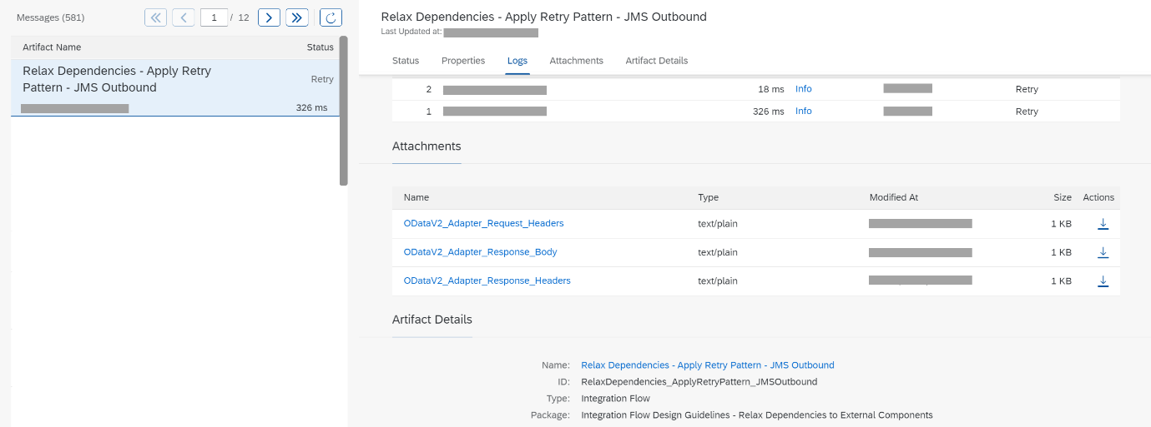
CPI stores:
- Message status
- Logs
- Payload snapshots (if tracing ON)
📌 Available in Monitor tab

🔁 FULL FLOW (ONE LINE)
Sender → Adapter → Process → Adapter → Receiver → Monitor

🧠 VERY IMPORTANT CPI RULES
🔑 Rule 1: Top-to-bottom execution
- No jumping
- Order matters
🔑 Rule 2: Payload is KING
- Most steps modify payload
🔑 Rule 3: Headers & Properties don’t auto-mix
- Explicit mapping needed

🎯 Non-Tech Explanation
CPI receives a message, understands it, applies business rules step by step, sends it to the right system, and keeps a record of everything.

🎯 Interview GOLD Answer
When a message enters SAP CPI, it is processed through adapters and integration steps in sequence, where payload, headers, and properties are handled, routed, transformed, and finally sent to the receiver with full monitoring and error handling.

✅ Self-Check (You’re Ready If…)
✔ You can explain CPI flow without UI
✔ You know where logic happens
✔ You know what adapters do
✔ You know when response is sent

🚀 Next: PHASE 2 (Hands-On Power)
- Content Modifier (deep)
- Headers vs Properties vs Variables (ultimate clarity)
- XPath (real practice)
- Router logic (business cases)

Step | Component | What it Does | Payload | Headers | Properties
1 | REST Client | Sends request to CPI | ✔ Sends | ✔ Sends | ❌
2 | HTTP Sender Adapter | Accepts request, authenticates, converts to CPI format | ✔ Reads | ✔ Reads | ❌
3 | Integration Process | Core container executing flow steps | ✔ Available | ✔ Available | ✔ Available
4 | Content Modifier | Sets/updates values for processing | ✔ Can modify | ✔ Can set | ✔ Can set
5 | Router | Evaluates conditions and routes message | ✔ Reads | ✔ Reads | ✔ Reads
6 | HTTP Receiver Adapter | Sends message to target system | ✔ Sends | ✔ Sends | ❌
7 | Receiver System | Processes final request | ✔ Receives | ✔ Receives | ❌

Perfect 👍
Below are the MODEL / IDEAL ANSWERS for ALL PHASE 1 HANDS-ONs — exactly how you should understand and revise them.
(Point-wise + tabular, no UI dependency)

✅ HANDS-ON 1
CPI Message Flow (Tabular)
Step | Component | What it Does | Payload | Headers | Properties
1 | REST Client | Sends request to CPI | ✔ Sends | ✔ Sends | ❌
2 | HTTP Sender Adapter | Accepts request, authenticates, converts to CPI format | ✔ Reads | ✔ Reads | ❌
3 | Integration Process | Core execution container | ✔ Available | ✔ Available | ✔ Available
4 | Content Modifier | Sets/updates values | ✔ Can modify | ✔ Can set | ✔ Can set
5 | Router | Evaluates conditions & routes | ✔ Reads | ✔ Reads | ✔ Reads
6 | HTTP Receiver Adapter | Sends message to receiver | ✔ Sends | ✔ Sends | ❌
7 | Receiver System | Processes request | ✔ Receives | ✔ Receives | ❌

✅ HANDS-ON 2
Payload vs Header vs Property
Item | Example | Purpose | Scope
Payload | Order JSON/XML | Business data | Sent to receiver
Header | Content-Type, Authorization | Technical / control info | Travels with message
Property | orderType, flag | Internal CPI logic | Inside iFlow only
Key Rule:
Payload = data, Header = control, Property = CPI logic

✅ HANDS-ON 3
SYNC vs ASYNC Classification
Scenario | Sync / Async | Why
Payment processing | SYNC | User waits for result
Order creation | ASYNC | Only acknowledgment needed
Login authentication | SYNC | Immediate validation required
Night batch job | ASYNC | Long-running, no user waiting
File transfer (SFTP) | ASYNC | Large data, background process

✅ HANDS-ON 4
HTTP Request Breakdown (CPI View)
Example Request
POST /createOrder
Headers:
Content-Type: application/json
Authorization: Bearer token

Body:
{
"orderId": 10,
"amount": 5000
}
Part | Meaning in CPI
Method | Action to perform (POST)
URL | Service endpoint
Headers | Auth, format, control data
Body / Payload | Business data
Response Code | Success / failure status

✅ HANDS-ON 5
CPI Monitoring & Error Scenario (Mental)
Scenario:
Receiver system fails and returns 500
CPI Behavior:
Question | Answer
Where is error logged? | Monitor → Message Processing Logs
Does CPI stop flow? | Yes, normal flow stops
Is Exception Subprocess triggered? | Yes (if configured)
What does sender receive? | Error response (500)
Retry possible? | Yes (mainly for ASYNC)
Key Insight:
CPI never hides errors — it logs everything

🧠 FINAL CONSOLIDATED UNDERSTANDING
Area | You Now Know
CPI message lifecycle | ✅
Data separation | ✅
Sync vs Async decision | ✅
HTTP structure | ✅
Error handling & monitoring | ✅

🏁 PHASE 1 – 100% COMPLETE ✅
You now have:
- Concept clarity
- Hands-on thinking
- Interview-ready answers

